## User guideline



### Login, Logout

#### Login

• Open app

• Choose “LOGIN WITH GOOGLE” or “LOGIN WITH FACEBOOK”

• Fill in with Google or Facebook information 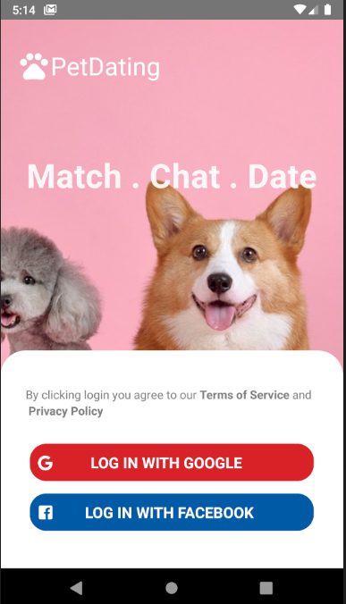

Figure 116 - Login interface

#### Logout

1. • Switch to Option tab
2. • Press “Sign out”

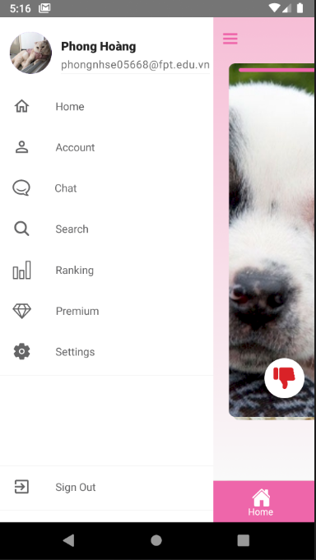

Figure 117 - Logout option in Option tab

### 6.2.2 Home page

After logging in, home screen will appear

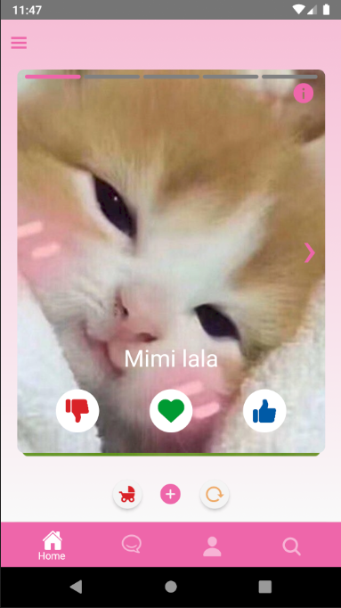

Press “i” in the upper right corner of the card to enter the profile

Here will display information about the pet and its owner

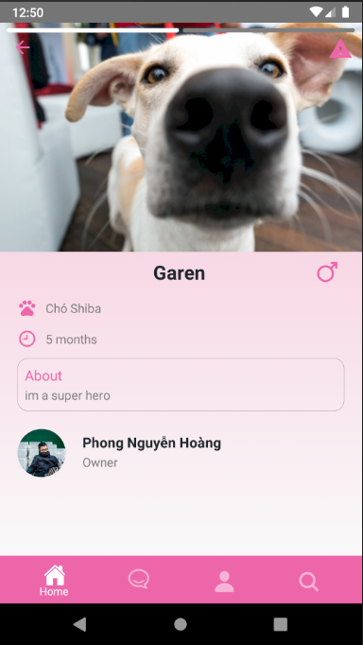

Press the button in the top right corner to report this pet

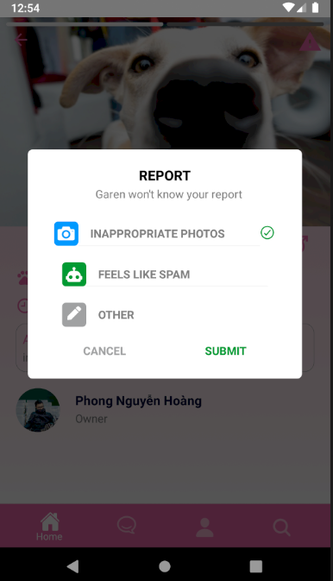

*** Press Like, Nope and Match underneath the card to interact with the pet on the screen

After the interaction is completed, it will switch to a new pet

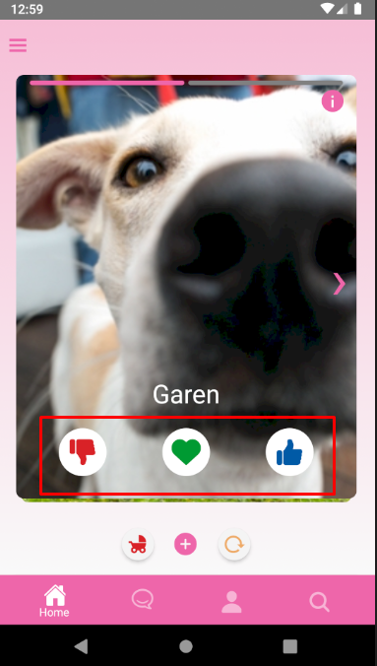

If you want to return to the pet you have just finished interacting with, press roll back ( Premium only )

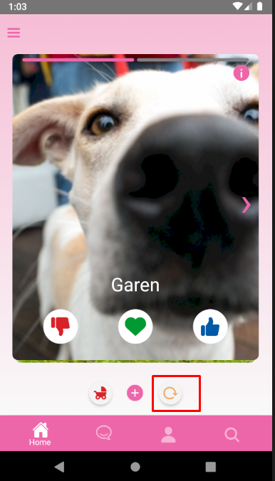

If you want to see pictures of children that your pet and other people's pets, press next generation ( Premium only )

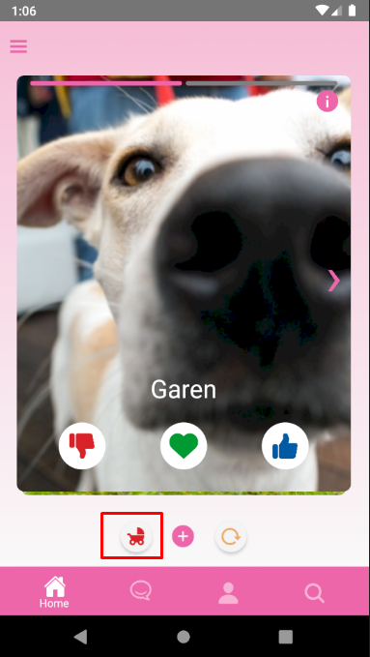

Edit your personal information

Fill information in text field

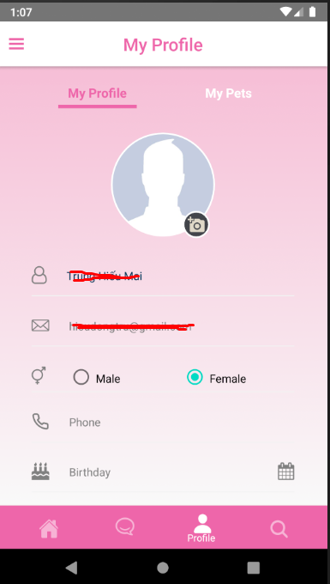

Press “Add a new pet” to add a new pet for yourself

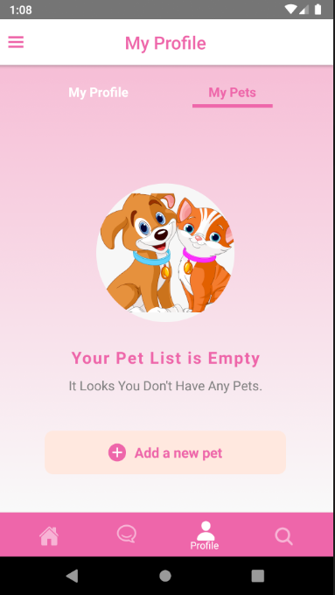

• Fill all needed information, and press “Submit” to create a new pet

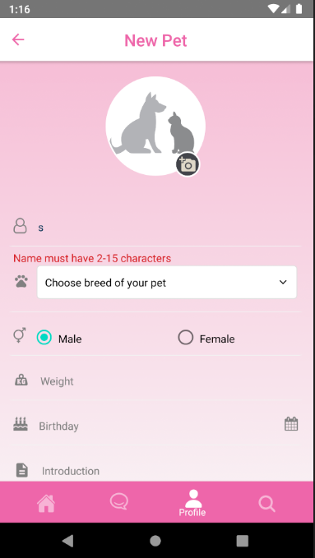

Drag the slider and click “Find” to find users with a radius of 1 to 100 km

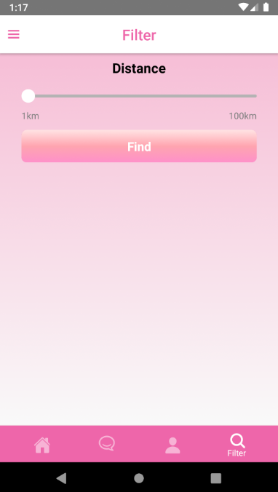

Press “Ranking” to see top 10 matched and liked

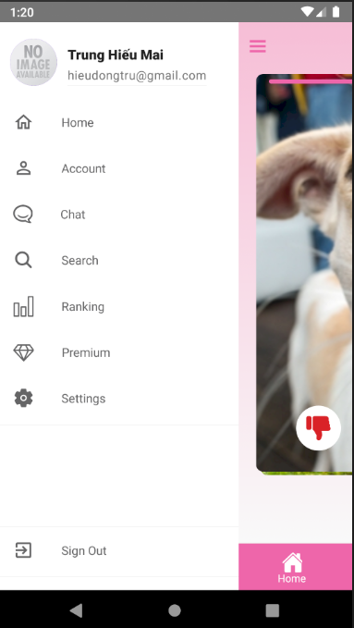

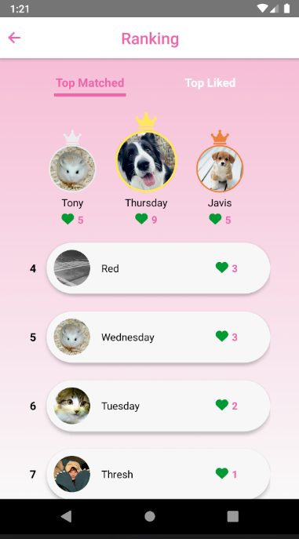

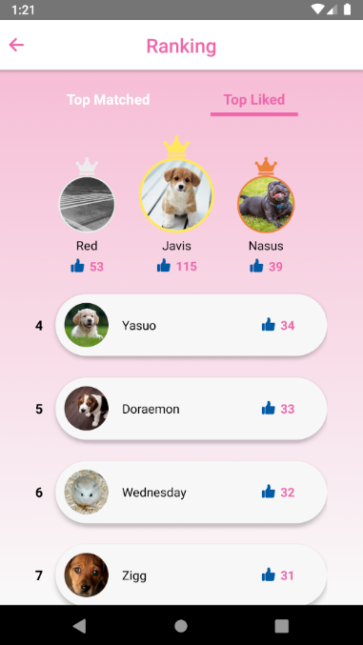

Press “Upgrade Premium” to upgrade your account from regular to premium to unlock all the features

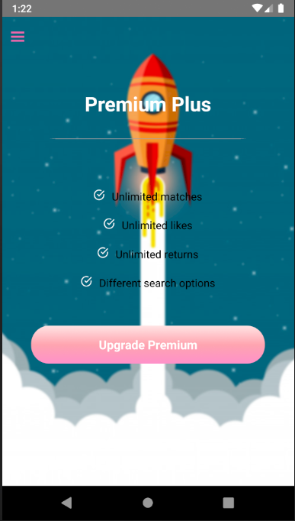

Press “Use Premium” 1 in 2 to choose which method you want to pay for premium upgrades

